The Clayton Museum – Please tell us what you think.
By filling in this questionnaire you agree for English Heritage and Sheffield Hallam University to use your answers as part of a research project aiming at improving the experience of visiting Chesters’ museum.
Section A: about you and your visit

Age: _____ Country: __________ If UK county: _____________

- Is this your first time at Chesters?
□ Yes □ No

- How much do you know about Roman culture and religion?
□ I consider myself an expert
□ I am an enthusiast
□ I know something
□ I know very little
□ I know nothing at all

- Are you visiting:
□ alone
□ with your partner
□ with your family (with children under 10 years old)
□ with your family (with children above 10 years old)
□ with friends
□ as part of an organised group

- How long did you stay in the museum for?
□ 0-5 minutes
□ 5-15 minutes
□ 15-30 minutes
□ more than 30 minutes

- Why did you come and visit?

--------------------------------------------------------------------------------------------------------------------------------------

Please turn over
Section B: only complete this if you used the Juno votive device (pictured below)

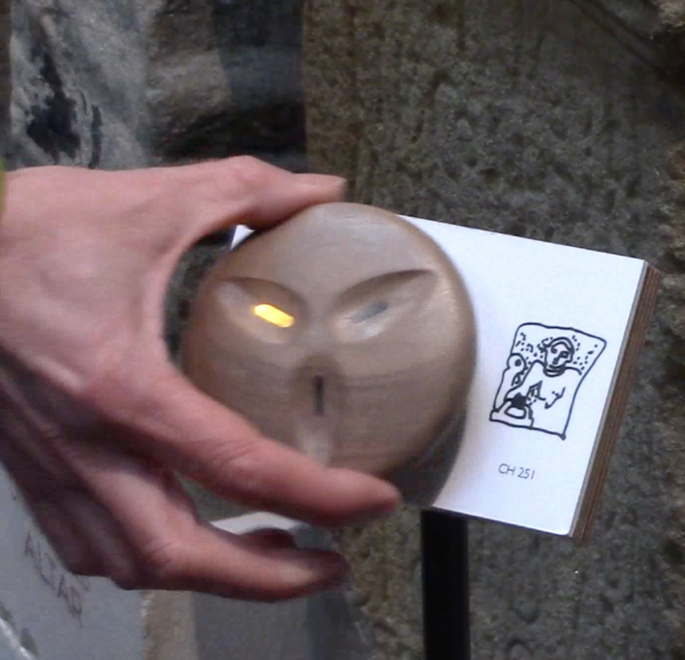
- How did you decide to which god you offered your light?
□ I know about Roman gods and religion so I knew who to choose
□ I read all the labels first, then I went back to the three I wanted
□ I read the labels as I went around and choose those I found interesting
□ I choose according to which statue or altar I liked
□ My choice was random,
□ Other (please specify):

______________________________________________

- What do you think about using the Juno device as part of your visit?
--------------------------------------------------------------------------------------------------------------------------------------------------------------------------------------------------------------------------------------------------------------------------------------------------------------------------------------------------------------------------------------------------------------------------------------------------------------------------------------------------------------------------------------------------------
Section C: what you’ve gained from your experience
- I have discovered a lot about Roman religion and the Roman gods. Do you…

3
1
4
5
strongly disagree
Strongly agree
Neither agree nor disagree
2
- I understand the purpose and significance of the stone objects. Do you…

3
1
4
5
strongly disagree
Strongly agree
Neither agree nor disagree
2
- I felt empowered to explore the museum during my visit. Do you…

3
1
4
5
Strongly disagree
Strongly agree
Neither agree nor disagree
2

11. I thought about the experience of Romans who used to live at Chesters. Do you…

3
1
4
5
strongly disagree
Strongly agree
Neither agree nor disagree
2
12. I felt a connection with the Roman people who once lived at Chesters. Do you …

3
1
4
5
Strongly disagree
Strongly agree
Neither agree nor disagree
2
13. I intend to find out more about Roman Britain. Do you …

3
1
4
5
strongly disagree
Strongly agree
Neither agree nor disagree
2
14. If applicable, I felt I shared the experience with my companion (s). Do you…

3
1
4
5
strongly disagree
Strongly agree
Neither agree nor disagree
2
15. Please tell us any other thoughts you have about your visit.

--------------------------------------------------------------------------------------------------------------------------------------------------------------------------------------------------------------------------------------------------------------------------------------------------------------------------------------------------------------------------------------------------------------------------------------------------------------------------------------------------------------------------------------------------------
Thanks! Your opinions are very important to us as they can help us improve what we offer.

